Project 2: Prep 1

Patterns:
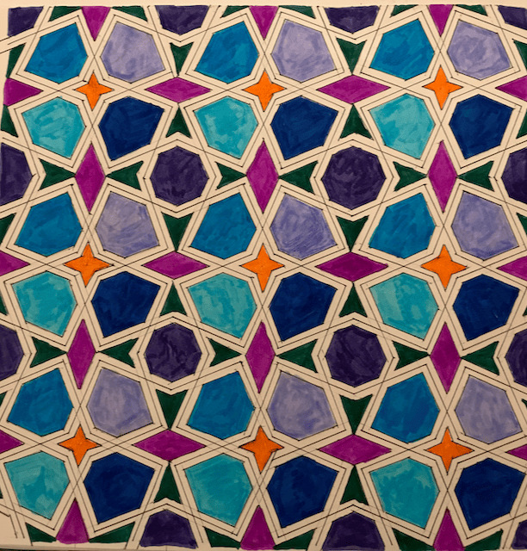
Islamic Geometric Patterns:
Islamic Geometric patterns are a form of non-figural decoration in Islam. They often appear in tapestries, architecture, and other Islamic art forms. I find these patterns really interesting because they're mathematically based and use simple shapes to create detailed works of art.

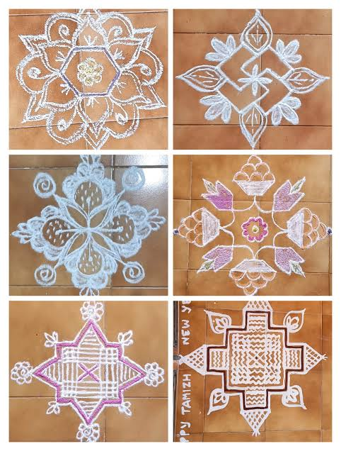
Kolam Patterns:
A traditional South Indian geometric floor art. People often draw them in front of the house daily in South Indian households using rice paste made from diluted flour. I think these patterns are interesting because they mimic organic shapes like flowers and plants using geometric forms.

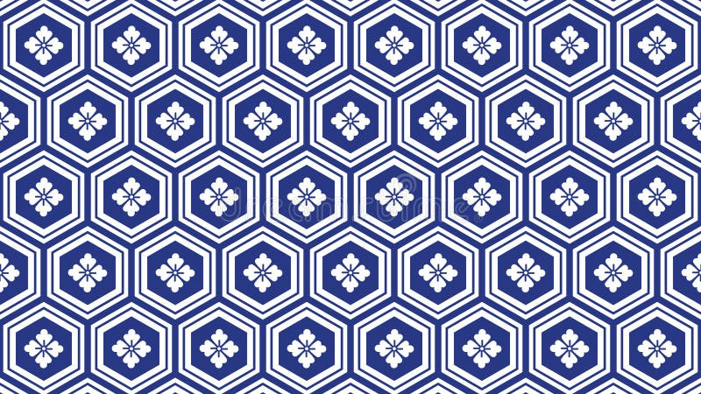

Kikko (Kikkoman):
A traditional Japanese geometric textile pattern inspired by the hexagonal shape of tortoise shells, an auspicious animal in Japan that symbolizes longevity. I find the repetition of this design fascinating because the positioning of the hexagons closely resembles a tortoise shell while still not adhering to a specific mould. I also feel there is a certain elegance behind its simplicity.

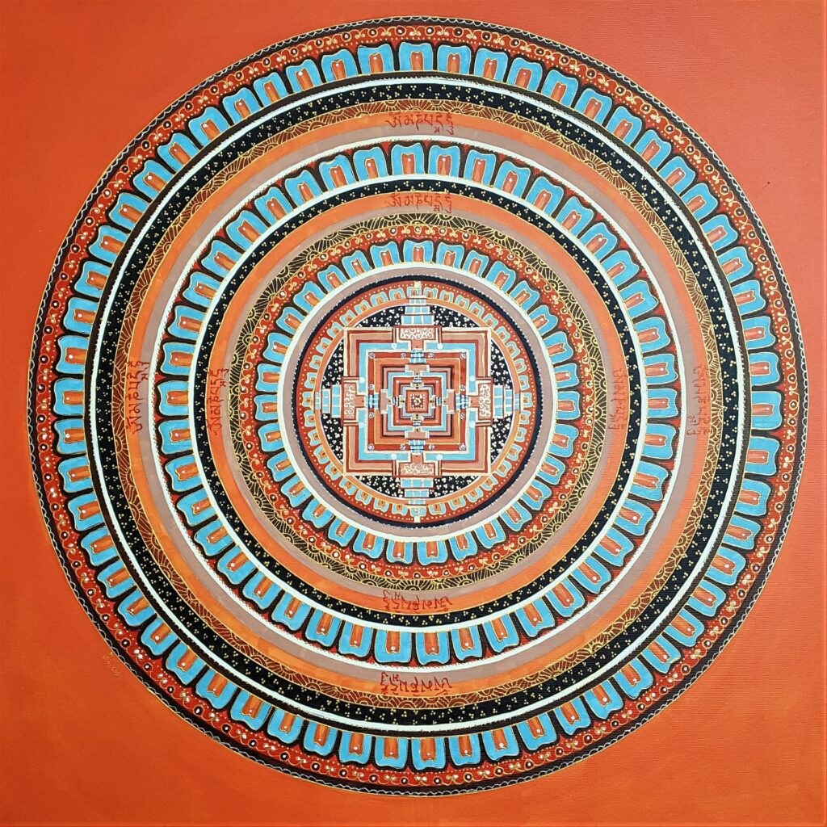
Nepalese Mandala:
A sacred geometric art form that is traditionally hand-painted on cotton cloth as Paubha or Thangka paintings. I find the circular, cyclical nature of mandalas fascinating, especially how it contrasts with the stricter geometric square at the center.

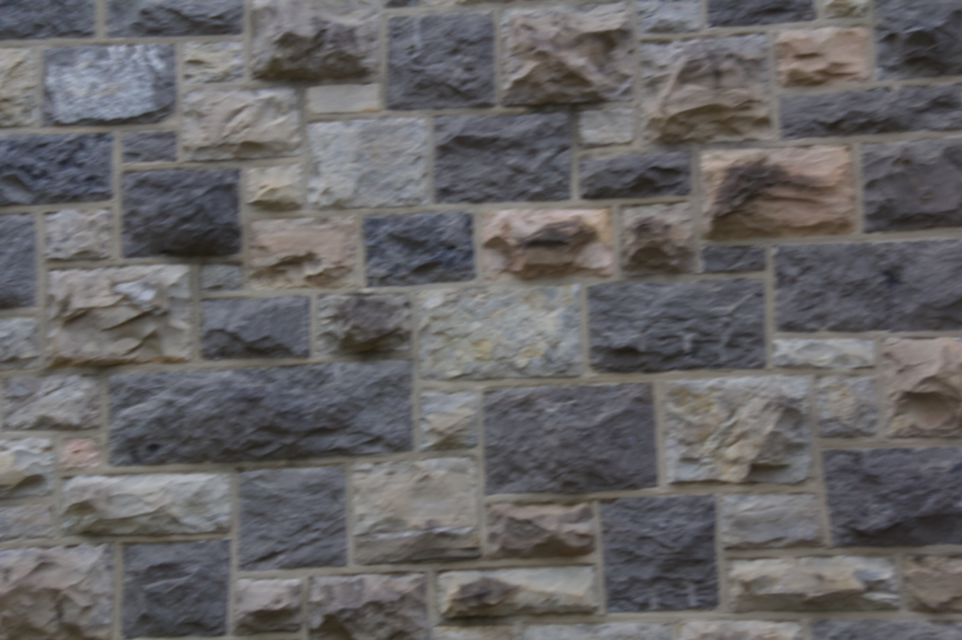
Hokie Stone:
Hokie Stone is a popular, retro stone used for many of Virginia Tech’s older buildings. I find the variety of colors and the number of different hues used in Hokie Stone fascinating. I also love the textures.

Random:
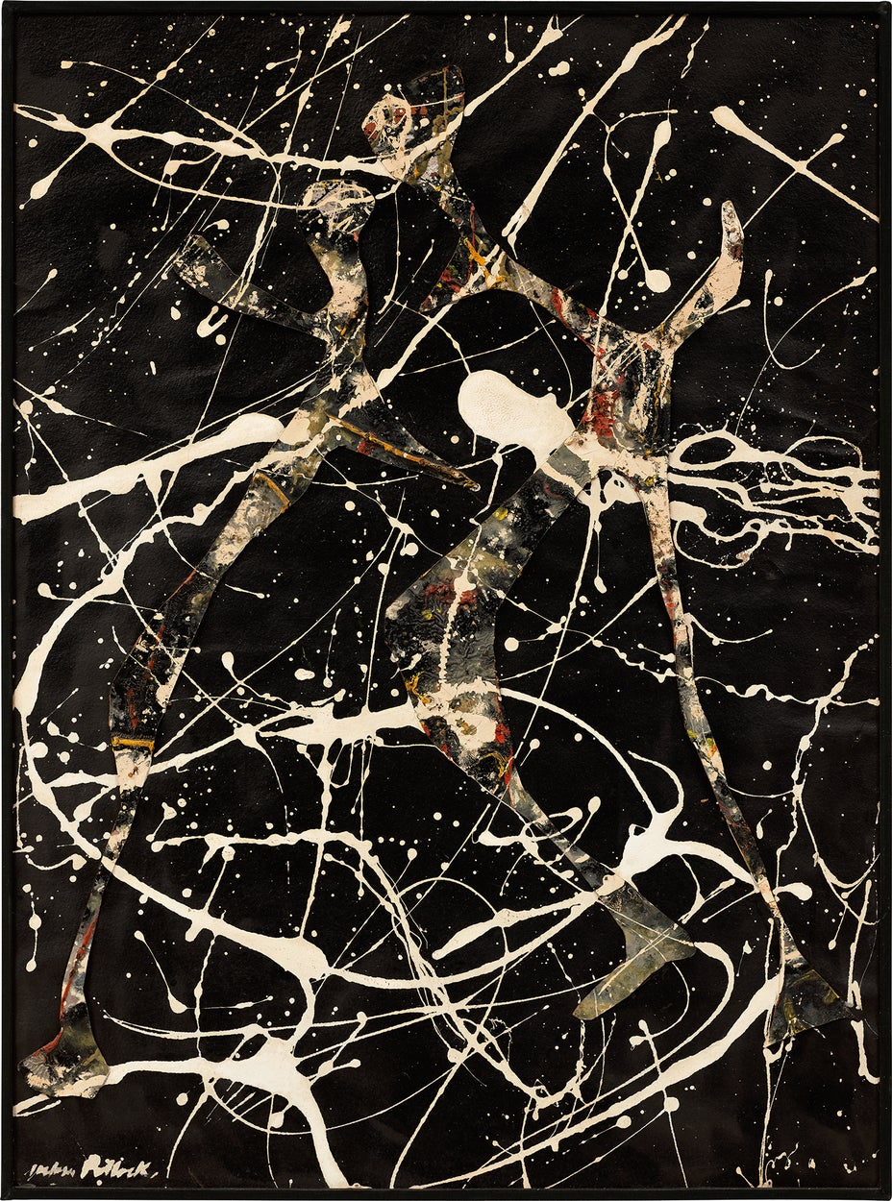

Lot 9 by Jackson Pollock:
Jackson Pollock was an American artist who was a major figure in the abstract expressionist movement. Much of his work was based on the idea of randomness and erratic movement of his drip technique. I find this work interesting because, while it uses a technique, most of the strokes are placed in random positions.

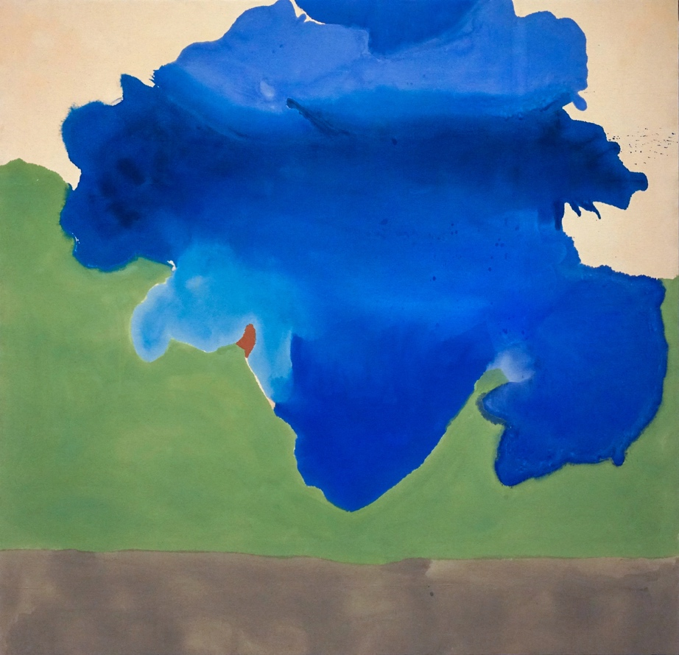

The Bay by Helen Frankenthaler:
Helen Frankenthaler is an American abstract expressionist painter. Her artwork, “The Bay”, is an example of her use of the soak -stain technique with acrylic paint. This work is interesting because the randomness came from how Frankenthaler lifted the canvas at a random angle to move the liquid paint across it.

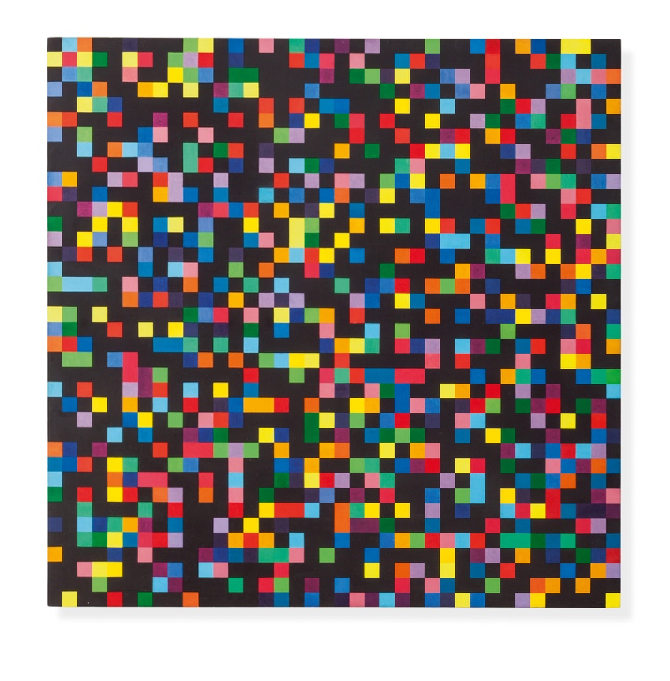
Spectrum Colors arranged by chance by Ellsworth Kelly
This work is part of a series in which Kelly took paper gommette, a type of sticky paper French schoolchildren used, cut it into squares, and arranged it in a 40-inch-wide grid. I find this work fascinating because of its experimental use of color and how it uses randomness to create an almost digital effect from physical media.

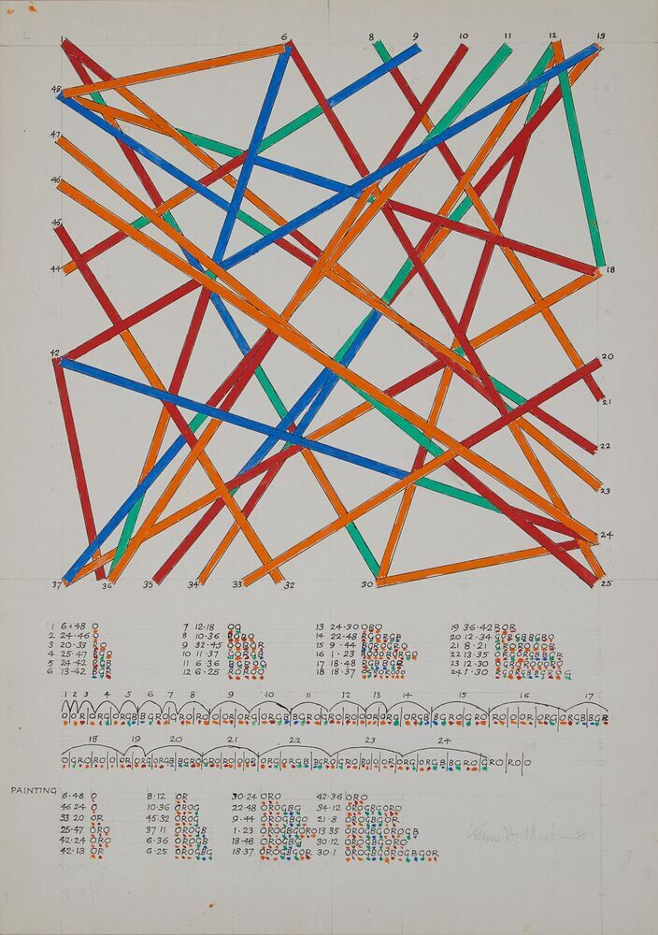
Chance and Order by Kenneth Martin:
For this series, Martin marked out a grid of squares and set rules for connecting the intersecting points, which he determined by a randomly selected card. I find this work interesting because the artwork turned out so abstract, despite the mathematical background behind it. I think the use of a randomly selected card leads to a more abstract artwork.

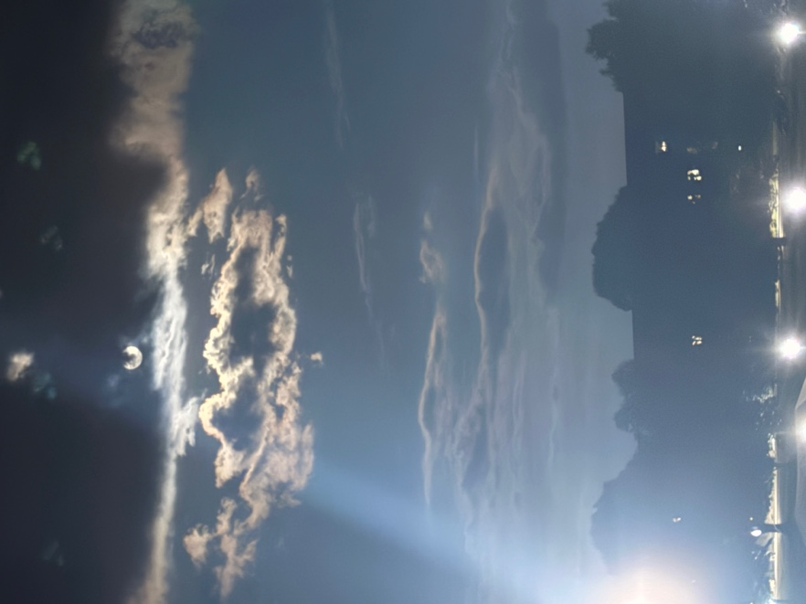
Clouds- photo by me:
This is a picture of clouds I took one night. I think that this is an example of randomness because the shapes, lighting, and wispiness of the clouds are not the same for each one. The variety of shapes signals the natural nature of the clouds. No process creates them; they just are.
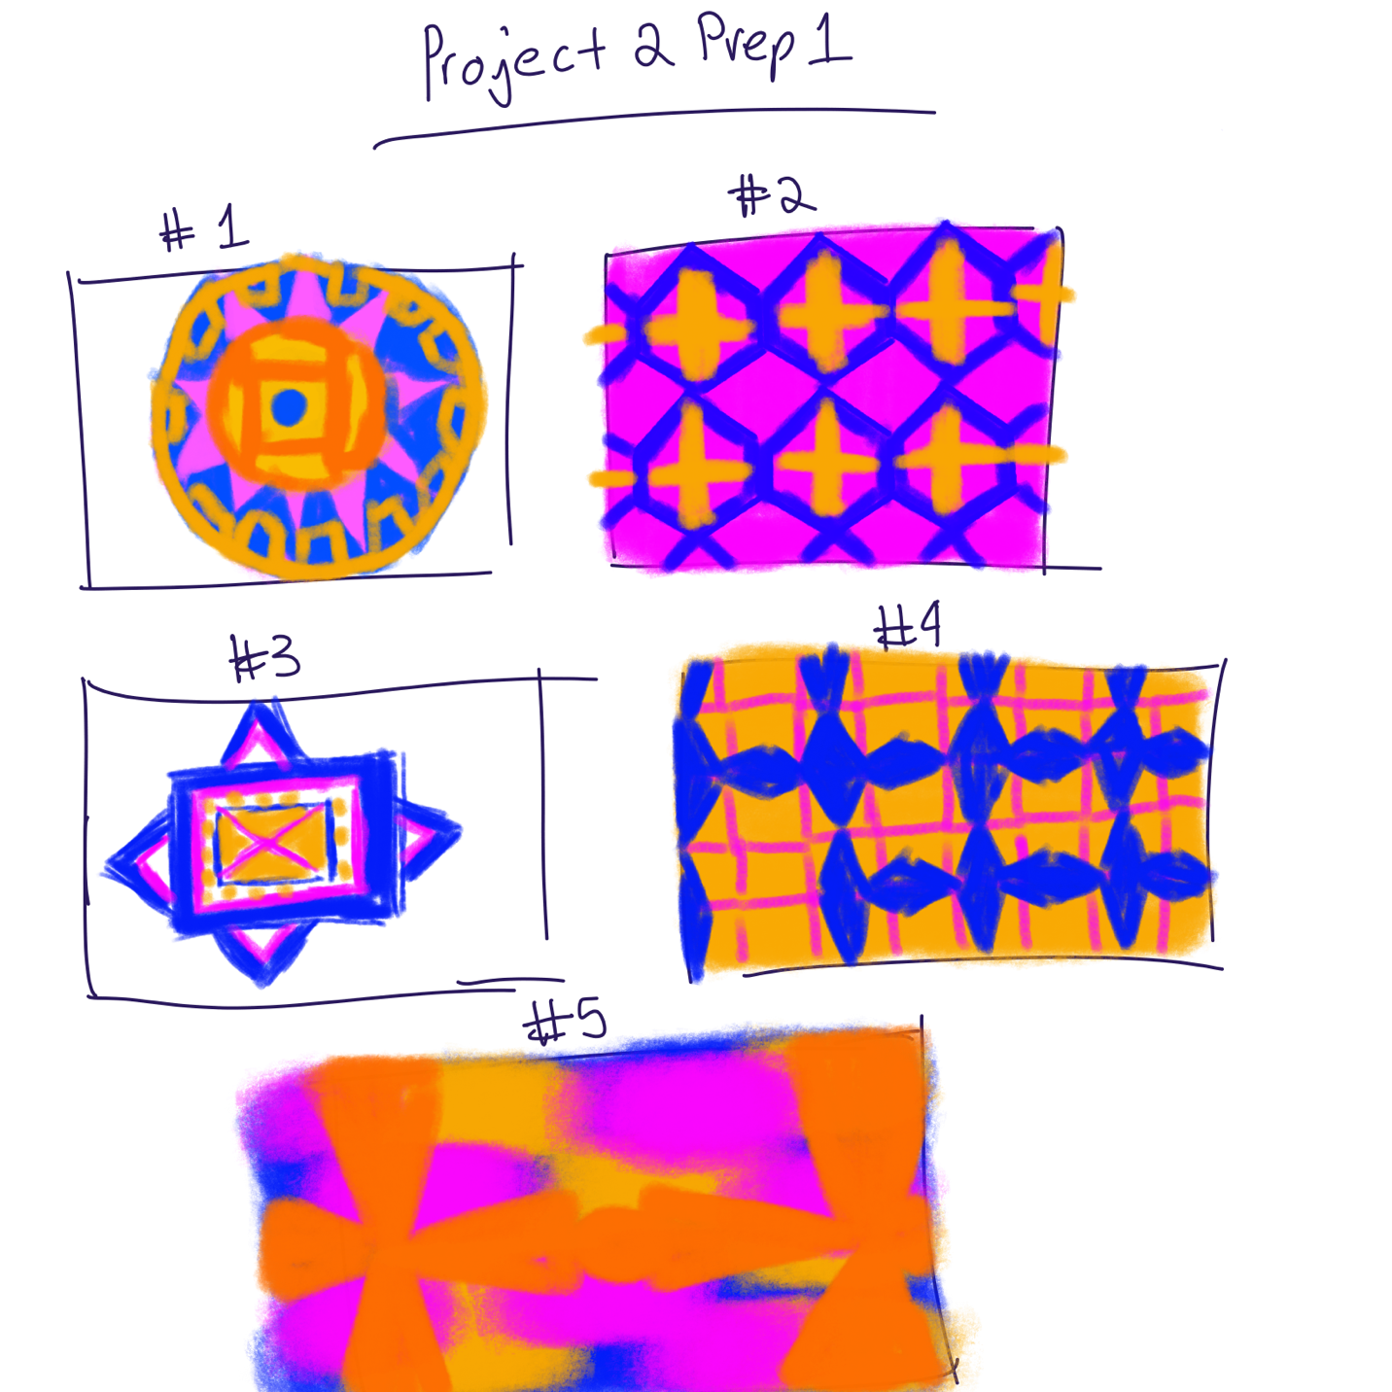

#1- This work is based on the Nepalese Mandala. I would use randomized colors and switch between the colors of the triangle and the lines on the square. I might also try to make the circular shape rotate.

#2- This is based of the kikko patterns. I would vary the stroke weight in the patterns, making it random. This way, the hexagons will vary in size while the cross in the middle stays the same.

#3 This is based on the kolam. The pink and the blue colors will switch between each other. I also feel like I would repeat the column design in the same manner as the Islamic patterns.

#4- This one is based on the Islamic patterns. I would make the fleur-de-lis in the design move to the top of the screen in the same pattern. I would also randomize the color of the background lines.
#5- This one is based on Hokie Stone. I would have the mixed colors of the rectangles and the circles change color and position. It would almost look as though it is glitching. I would try to keep the Hokie Stone patterning, though.

